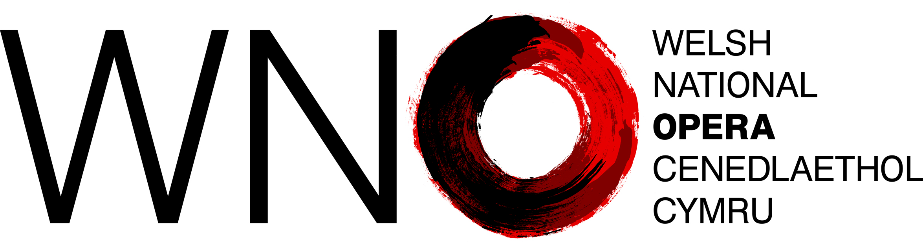

Welsh Language Standards

Annual Report for the year 2024-25

Who we are
We are Welsh National Opera (WNO), we are proud to be the national opera company of Wales and the largest provider of touring opera across the UK.
Our mission is to bring the power, drama and raw emotion of opera to as wide an audience as possible in performances, marked by an uncompromising quest for artistic quality.
As a national company with international status, we sit at the heart of music-making in Wales
We recognise that the culture of Wales is rooted in the Welsh language and the rich choral and musical tradition that is associated with the Welsh language and its communities.
Beyond the theatre, WNO connects with young people, schools and communities through its extensive education work and digital projects.
WNO and the Welsh language
The Welsh language is important to us as a company, and it is part of what makes us unique – through our influence and status we feel we have a part to play in promoting the language to our audiences in Wales and further afield.
WNO fully recognises its responsibility to comply with the Welsh Language Standards.
WNO understands Welsh Government’s ambitions to secure the future of the language, and ambition to see a million Welsh speakers by 2050.
WNO also recognises that the Welsh language is a key component of the Well-being of Future Generations (Wales) Act 2015 and in particular: “A Wales of vibrant culture and Welsh language – a society that promotes culture, heritage and the Welsh language, and which encourages people to participate in the arts, sports and recreation.”
Contact
Please contact us on cymraeg@wno.org.uk if you would like further information about this report or our Welsh language provision.

Overview
Our Welsh Language Standards came into effect in January 2017, since then, we have worked to put processes and procedures in place to ensure compliance with a total of 136 standards as detailed in our Compliance Notice.
We are committed to the aims of the Standards and meeting the needs of Welsh speakers
This report provides an overview of our activities related to complying with the requirements of the Welsh language standards during the 2024-25 financial year.
Service Delivery Standards – in focus
The service delivery standards set out how we provide services for our audiences and wider public in Welsh, ensuring they are as easy to access as those offered in English. These standards cover areas such as dealing with correspondence, online content, education courses and customer interactions. Their purpose is to give Welsh speakers the choice to use the language in their dealings with us.
Our compliance notice contains a total of 57 service delivery standards.
During the reporting period, we received no complaints in relation to the way we comply with the standards within this area.
Policy Making Standards – in focus
The policy making standards require us to consider the effect of our decisions, policies, and initiatives on opportunities to use the Welsh language, and on treating Welsh no less favourably than English. These standards ensure that the potential impacts on the Welsh language are assessed at the earliest stages of decision-making, so that our policies contribute positively to its use and promotion in everyday life.
Our compliance notice contains a total of 9 policy making standards.
During the reporting period, we received no complaints in relation to the way we comply with the standards within this area.
Operational Standards – in focus
The operational standards set out how we must use Welsh within our internal operations, ensuring the language is visible and actively used in the workplace. These standards cover areas such as Human Resources, policies, training, and providing resources for staff, so that Welsh is embedded in our organisational culture and treated no less favourably than English in our day-to-day operations.
Our compliance notice contains a total of 42 operational standards.
During the reporting period, we received no complaints in relation to the way we comply with the standards within this area.

Operational Standards – specific reporting requirements
Standard 132 – In line with the requirement of this standard, we consider the need for Welsh language skills for every new post or vacancy we advertise. During the reporting period we advertised a total of 20 posts, they were classed as follows:
Total No. of post advertised during reporting period | 20
Posts where Welsh language skills were essential | 0
Posts where Welsh language skills were desirable | 20
Posts where Welsh language skills needed to be learnt when appointed to the post | 0
Posts where Welsh language skills were not necessary | 0
Standard 123 - In line with the requirement of this standard, we keep a record of the Welsh language skills of our staff. Based on a self-assessment questionnaire, the number of employees who assessed themselves as having Welsh language skills are as follows:
Total number of staff at the end of the year | 279
Welsh language skills | No. | %
Staff with Welsh language listening, reading, speaking and writing skills, based on self-assessment | 52 | 19
Staff with no skills or yet to complete assessment at the end of the year | 227 | 81
This is an area which we have identified as requiring further work over the coming 12 months so that we are better able to understand the actual level of Welsh language skills for those reporting.
Standard 124 – In line with the requirement of this standard, we offer training in Welsh in the following areas, when training is provided in English:
- Recruitment and interviewing
- Performance management
- Complaints and disciplinary procedures
- Induction
- Dealing with the public
- Health and safety
During the reporting period, none of the attendees for the relevant courses noted that they would wish to receive the training through the medium of Welsh.
Further to the above reporting requirements, we also note that , as required by standard 128, during the reporting period Welsh Language awareness briefings were provided to staff which covered the history of the language and its role in Welsh culture as well as a detailed overview of the Welsh language standards and how the language can be used in the workplace.
The All-Wales Strategy Group, involving representatives from across WNO, began developing an organisation-wide cultural strategy to embed Welsh language and culture in programming, community engagement, partnerships, and communications. Preparatory work is underway to increase internal use of language and expand Welsh-language learning opportunities for staff.
Beyond compliance
For WNO the Welsh language standards are only part of the story, we strive to go beyond compliance, exceeding our commitments and seeking new ways of embracing and promoting the Welsh Language. During the reporting period, we undertook a range of activities beyond our formal compliance obligations under the Welsh Language Standards. These initiatives actively promoted the language across our artistic, engagement, and organisational work, strengthening our role as a cultural ambassador for Wales.
- Commissioning and Showcasing Welsh-Language Creativity
We commissioned a new bilingual Youth Opera, scheduled for performance at the New Theatre, Cardiff. This production, featuring 50% of the libretto in Welsh, includes BSL interpretation, blind performers, and disabled young people, ensuring accessibility and inclusivity. The work engages 80 young performers and a creative team comprising Welsh-language composer, director, and writer, with design elements informed by the young participants’ own ideas.
- Expanding Community Choirs with Bilingual Repertoire
The Cradle Choir programme for older people with dementia and their carers expanded to three locations (Milford Haven, Llandeilo and Llanelli), incorporating bilingual repertoire and intergenerational work with local schools. Across 20 sessions, 350 participants engaged in performances in heritage and community venues, with carers reporting the sessions as “the highlight of their week.” A small bilingual opera was also co-created with children in partnership with Swansea Bay Health Board.
- Redesigning WNO TEACH for the New Curriculum
We piloted a redesigned WNO TEACH programme to align with the Expressive Arts Curriculum and Well-being of Future Generations Act. The new format includes singing, performance skills, composition, and design, and reached 300 pupils in 20 schools, 4 of those being Welsh-medium.
- Welsh-Language and Bilingual Events at National Festivals
We delivered sold-out performances and workshops at the Hay Festival and National Eisteddfod, with Associate Artists and orchestral players engaging audiences through Q&As and interactive sessions. At the Eisteddfod, our partnership stall with Ty Cerdd, Anthem, and RWCMD provided further opportunities to promote our commitment to the language and connect with new audiences.
- Talent Development for Welsh-Speaking Artists
We increased the appointment of Welsh-speaking artists, vocal leaders, and creatives by 15%, including roles within the Associate Artist programme, youth opera, and community projects. This included appointing a Welsh-language presenter for schools’ concerts and commissioning Welsh-speaking creatives for main stage and engagement projects.

