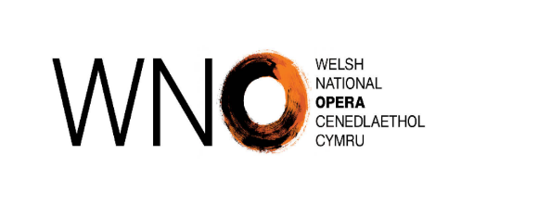 |  | Welsh Language Complaint Form
WNO is committed to dealing effectively with any concerns or complaints members of the public may have about our compliance with the Welsh language standards.

Please complete this form outlining your complaint relating to our compliance with the Service Delivery, Policy Making and Operational standards with which we are under a duty to comply.

Name
Contact details | Address
Contact details | Phone Number
Contact details | Email
How would you like us to contact you regarding this complaint? |  |  | Phone
 |  |  | Email
 |  |  | Letter
Which language would you like us to use when we contact you? |  |  | Welsh
 |  |  | English
YOUR COMPLAINT
Nature of the complaint
Details (Please include as much information as possible – include pictures if applicable)
Date
Location (if applicable)
What do you think should be done to put things right?
Signature
Date
Please return this form to cymraeg@wno.org.uk or ‘Cwyn Iaith’, Welsh National Opera Wales Millennium Centre, Bute Place, Cardiff Bay, CF10 5AL.
Complaints will be acknowledged within 5 working days

